**Apache Tomcat v11.0 Server Setup in Eclipse**

**1. Preferred IDE**

Eclipse IDE is used for the project setup.

**2. Server Setup in Eclipse**

Go to the top menu: Window > Show View > Servers.

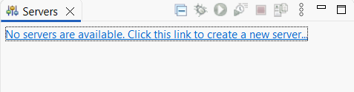

Click on 'Create a new server'.

In the 'New Server' wizard, select Apache > Tomcat v11.0 Server.

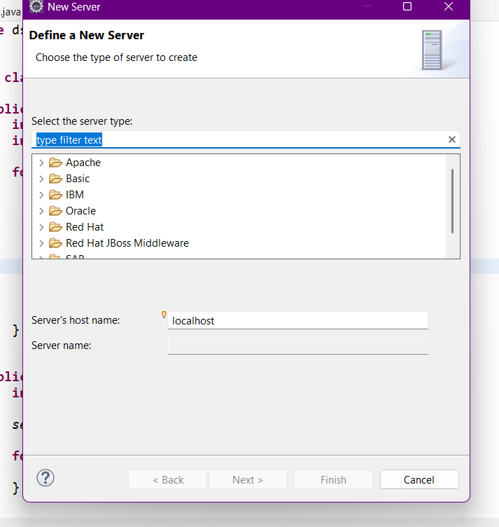

Click 'Next'.

Browse to the directory where Apache Tomcat v11.0 is installed on your system (e.g., C:/apache-tomcat-11.0.x).

If not already downloaded, get it from https://tomcat.apache.org/download-11.cgi and extract it.

Click 'Next' and then 'Finish'.

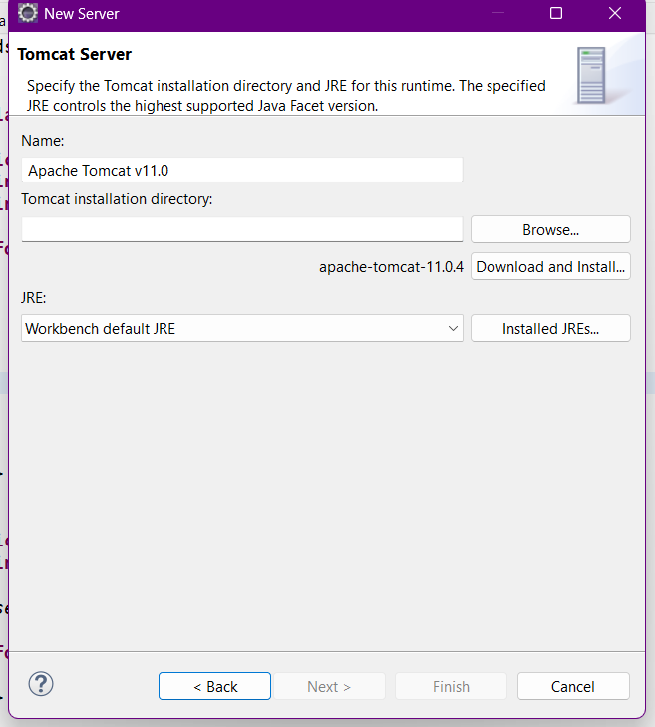

Your server setup is now complete.

**3. Linking Tomcat Runtime to the Project**

Right-click your project in the Project Explorer and choose 'Properties'.

Go to 'Targeted Runtimes'.

Check 'Apache Tomcat v11.0'.

Click 'Apply and Close'.

**4. Configure Project Facets**

Right-click your project > Properties > Project Facets.

If not already enabled, click 'Convert to faceted form...'.

Set 'Dynamic Web Module' to 5.0 or 6.0 (for Jakarta EE).

Ensure 'Java' is set to 11 or above.

Click 'Apply and Close'.

**5. Optional: Troubleshooting**

If the server does not start, make sure the configured port (e.g., 8085) is not already in use.

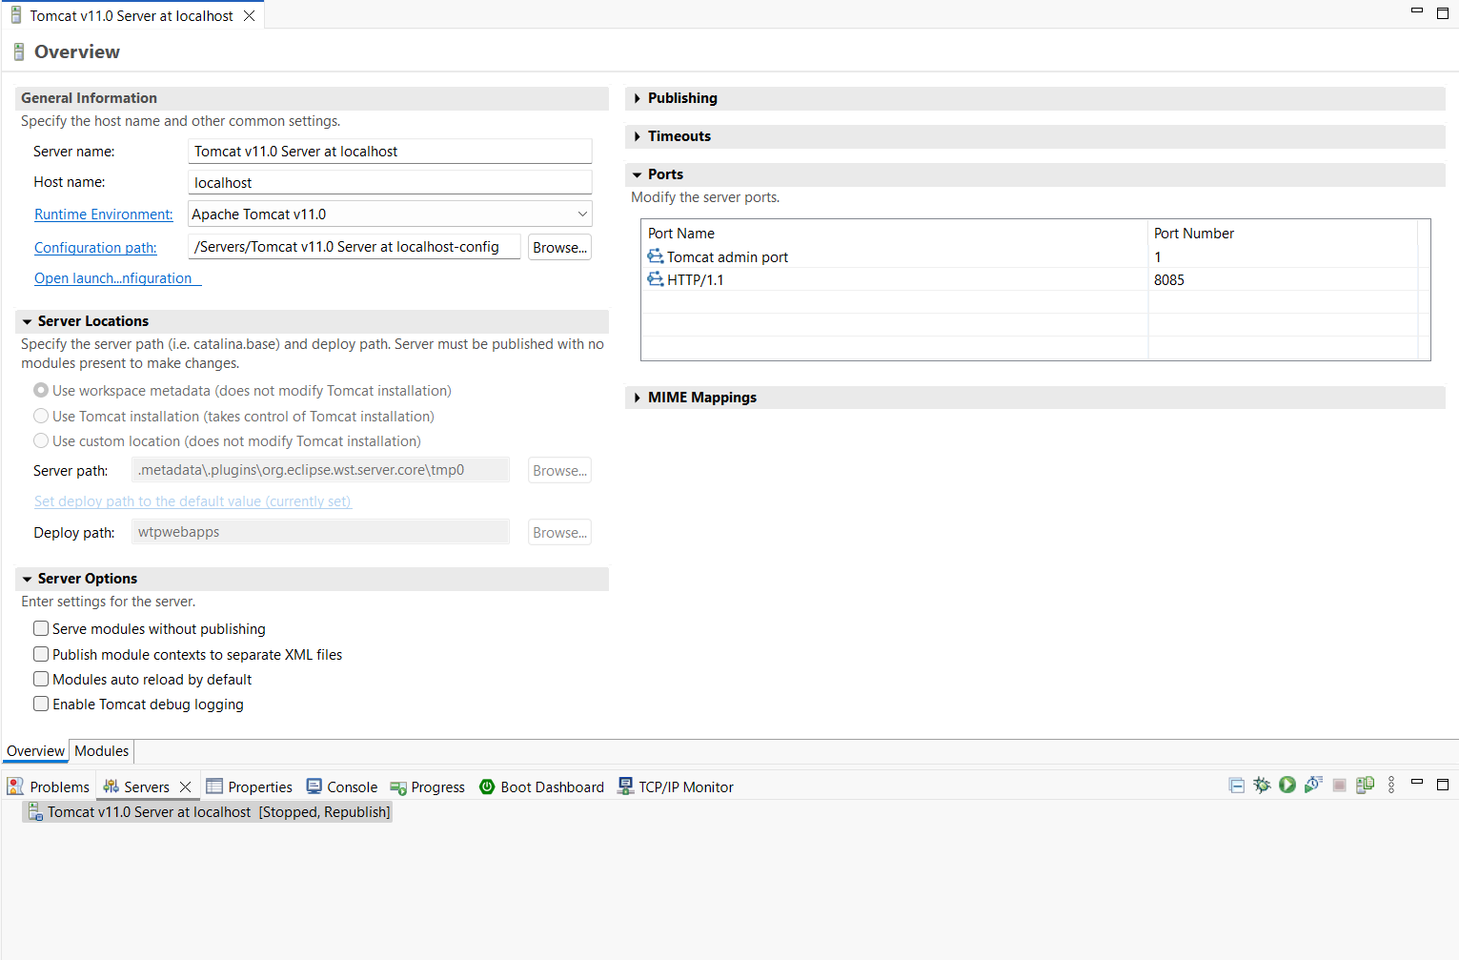

If you get an error like 'javax.servlet.http.HttpServlet not found', make sure you are using Jakarta Servlet API.

Add the correct Jakarta Servlet Maven dependency in your pom.xml:

<dependency>  
 <groupId>jakarta.servlet</groupId>  
 <artifactId>jakarta.servlet-api</artifactId>  
 <version>6.0.0</version>  
 <scope>provided</scope>  
</dependency>

Update your project: Right-click → Maven → Update Project.

Clean and rebuild your project if necessary.